PG - Training and Placement Cell

Ms. Saileja Sevella
Coordinator for PG
Placement Officer
Mobile: 9705149831
Email Id: sailejasevella@gmail.com

Profile:
The Training and Placement Office for the PG students of the University College for Women, Koti keeps its persistent efforts to provide the students placements in organizations which offer great career to our students. As our institution being a prestigious and constituent college of Osmania University, considerable number of students from rural back ground also take admission into our college every year. We inculcate good attitudes; make the students technically strong and industry ready through regular Training and Development sessions.
Objective:
The primary objective of our Training and Placement Office is to reduce the skill gap by organizing regular training sessions to students ranging from Resume writing, inculcating professional attitude to personality development. We also guide them in career planning so that they remain in organizations for a longer period of time. One of our important objectives is to provide required training to students from rural background, get them placed in good Organizations and supporting them in empowering themselves financially.
Placement Activities:
- Organize Training for Resumes Writing, inculcating professional behaviour, personality development.
- Reducing the skill gap by making them industry ready.
- Provide career guidance and counselling foe career development.
- Agility in transforming the Talent pool with competent and proactive training systems and delivering them to dynamic business world.
- To provide successful employment opportunities, including entrepreneurship and self-employment, to the students, most appropriate with their specialization and calibre.
- To transform students with the advent of right industry skills in order to prepare them to face the interviews competently and succeed.

PG-Training and Placement Cell is formed on 15th September 2021 with 8 members.

Our Placement Team for PG
Coordinator for PG Placement Officer | Ms. Saileja Sevella, Assistant Professor (C) | Department of Business Management
Team Members
Mrs. T. P. Pavani | Assistant Professor (C) | Department of Business Management
Mrs. D. Mayuri | Assistant Professor (C) | Department of Business Management
Dr. Nalini | Assistant Professor (C) | Department of Commerce
Dr. M. Santoshi Lakshmi | Assistant Professor (C) | Department of Food and Nutrition
Mrs. P. Sowmya | Assistant Professor (C) | Department of Computer Science
Dr. N. Kavitha | Assistant Professor (C) | Department of Chemistry
Mr. B.V.Krishnaji Rao | Assistant Professor (C) | Department of Mass Communication

The mission of the PG-Training and Placement Cell is –

“To transform the fresh potentials into productive human capital through a dexterous talent transformation ecosystem”

It is achieved by our unique model of engaging students, leadership and career development, personal growth, inclusiveness and finally to successful placement. The PG-Training and Placement Cell at UCE is to place of transformation of maximum number of students into successful professionals and launch themselves in various reputed IT and non-IT core manufacturing, infrastructure companies. To achieve this goal, the department has a continuous interaction with industries to have an idea of what the industries expect from our students.

“SUCCESS THROUGH ENGAGEMENT & INVOLVEMENT”

Training and Placement Cell provides multiple vistas of opportunity to balance physical, emotional, and social well-being through participation in events, student organizations & voluntarism during our on-campus and off-campus employment services. T&P creates innovative programs to allow students to share and learn the latest technological insights in the college by experiencing programs like industry visits, experts and mentors coming from industry and interacting, internship opportunities etc.
- In addition, T&P coordinates the activities like arranging on Job training, industrial visits and career guidance lectures to students. The Training and Placement Cell also guides the students in professionalism, presentation techniques, group discussion techniques interview skills and new technology trends and developments in the industry.
- The Training and Placement Cell is committed to building a sense of community on campus through partnerships with academic departments, alumni, and business leaders. In addition, personnel of T&P are devoted professionals who strive to develop a meaningful and lasting camaraderie among students.

Virtual Interview during September to December 2021
Name of the company conducted Virtual Interview | Number of students attended the interview | Number of students placed
Ryan Tax Service Private Limited | 21 | 01
Global Research centre Private Limited | 26 | -
First Meridian Business Services Limited | 13 | 02
Factset systems India private LTD | 28 | -
Tata Consultancy Services | 34 | -
Cyient Company | 59 | -
Sieve Softech | 52 | -
SRS Business solutions India Private Ltd | 13 | 02
Vasista Enterprise Solutions Private Limited | 28 | -
TA Digital | 43 | -

- Pool campus drive was organised on 5th December 2021 at University college for women in collaboration with Reliance Retail (Jio Mart) for MBA marketing and B.COM students. Around 88 students attended the drives among them 24 students were shortlisted. Among 24 students, 14 were from University college for Women got shortlisted i.e., 1 from MBA and 13 from B.com 2022 pass out Batch.

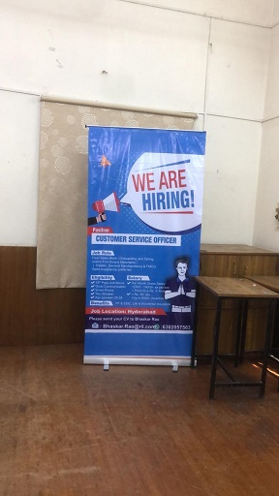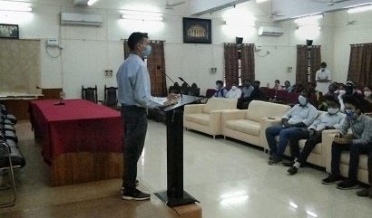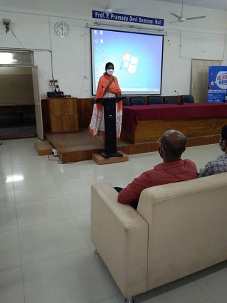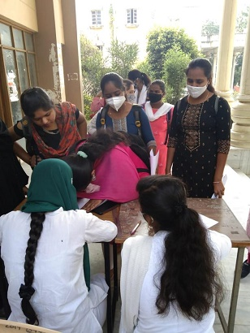

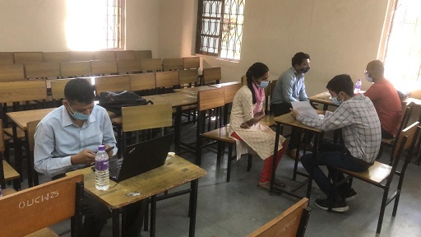

- PG-Placement cell organised Mega On-Campus Drive in collaboration with Magic Bus to UG and PG students on 18th December 2021 at PG Seminar Hall with 14 companies and 171 students attended the drive.

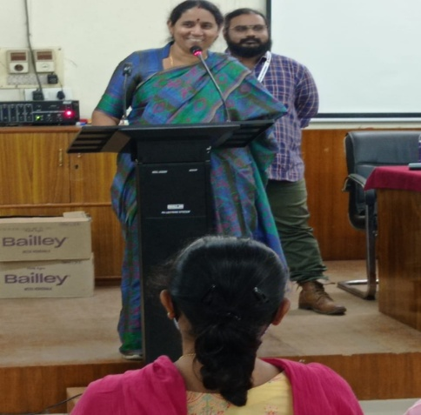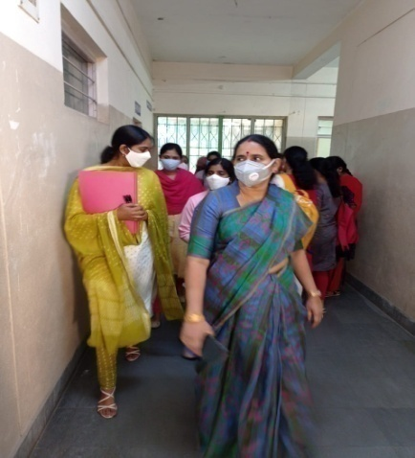

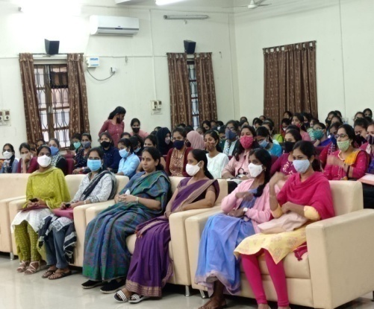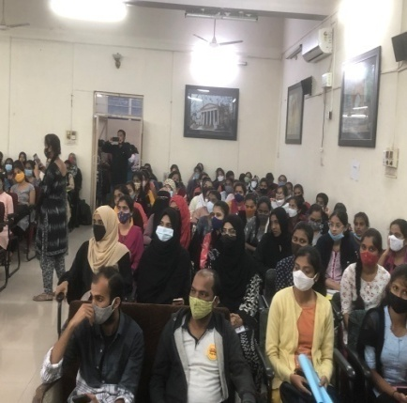

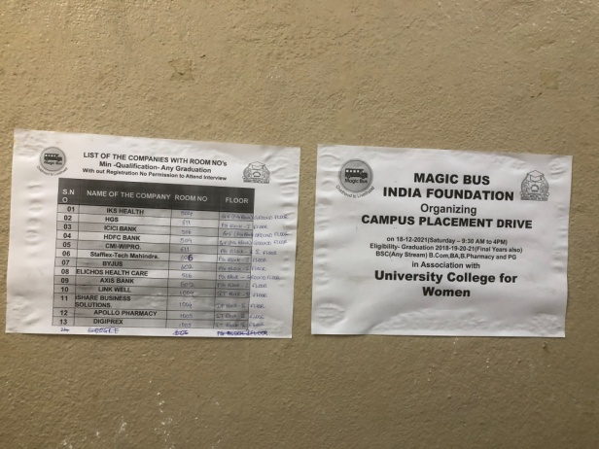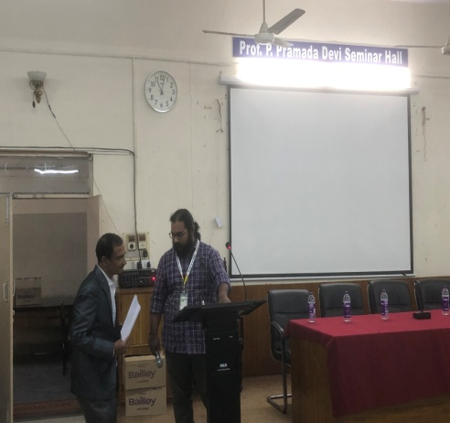

Name of the companies for Mega On-Campus Drive on 18th December 2021
HGS
IKS Health
Tech Mahindra
Byjus
Axis Bank
HDFC Bank
Elichos
ICICI Bank
ishare Business Solutions
Link well
Apollo Pharmacy
Digiprex
IKS Healthcare
HESA

Results are awaiting

- PG-Placement cell organised ADP On-Campus Placement Drive for UG and PG students on 20th December 2021 at PG Seminar Hall for 357 students.

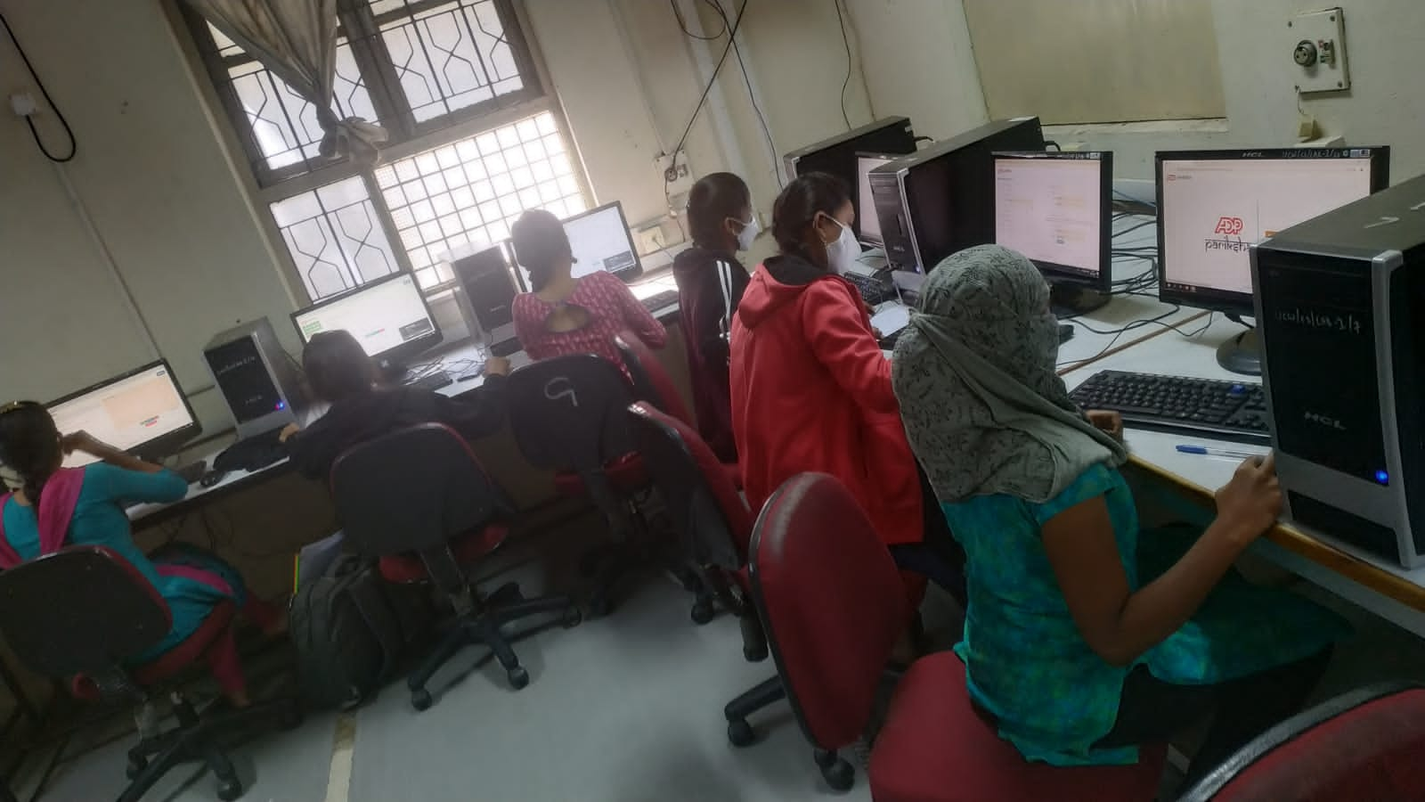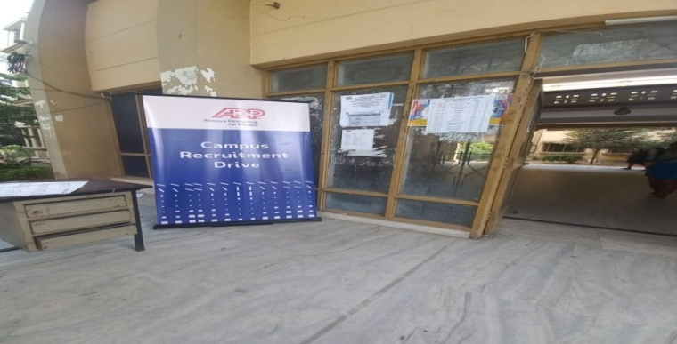
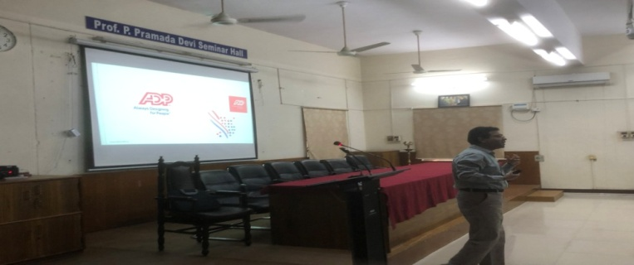

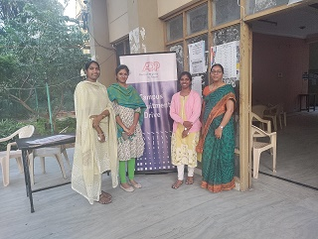
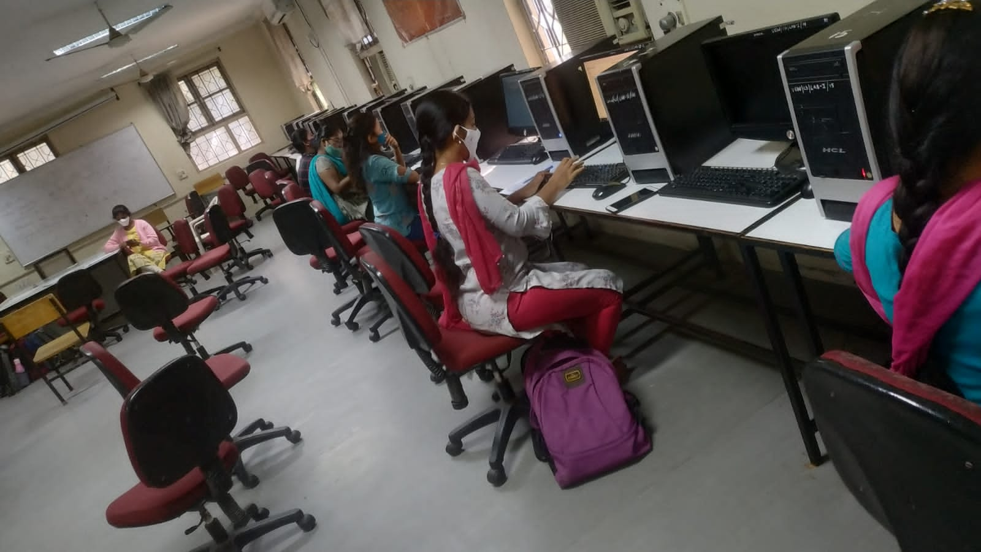
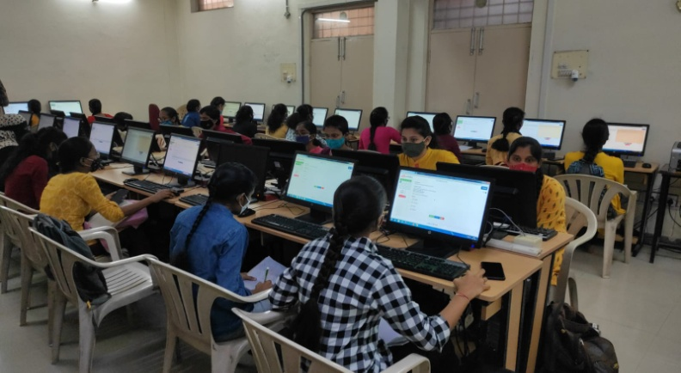

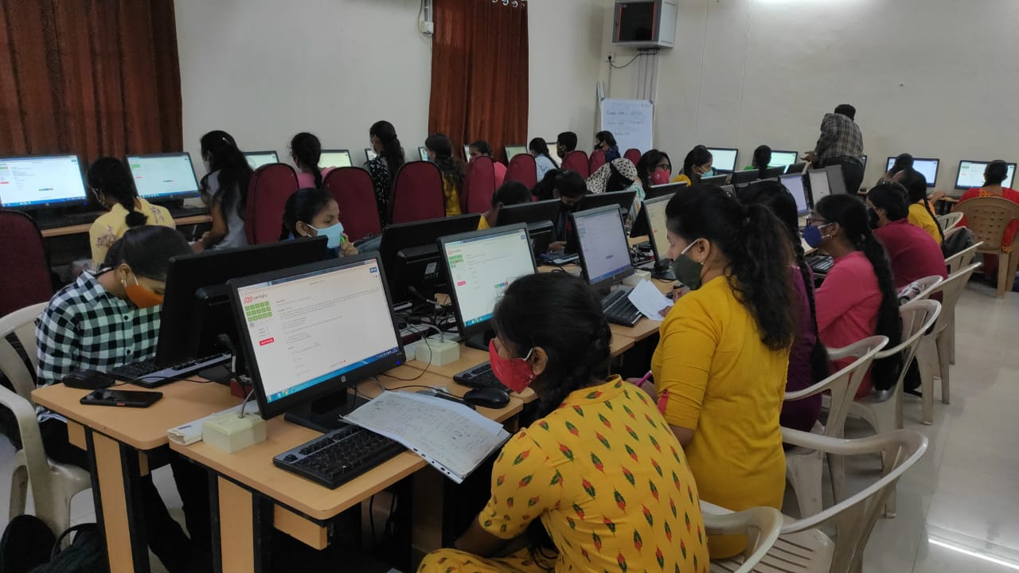

Results are awaiting.

It is achieved by our unique model of engaging students and other members of the VCE community in processes & programs which support learning, leadership and career development, personal growth, inclusiveness and finally to successful PLACEMENT. The Training and Placement Cell at VCE is to place of transformation of maximum number of students into successful professionals and launch themselves in various reputed IT and non-IT core manufacturing, infrastructure companies. To achieve this goal, the department has a continuous interaction with industries to have an idea of what the industries expect from our students. On average 86% of eligible students with average marks more than 60% get placed through campus placements.
“SUCCESS THROUGH ENGAGEMENT & INVOLVEMENT”
Training and Placement Cell provides multiple vistas of opportunity to balance physical, emotional, and social well-being through participation in events, student organizations & voluntarism during our on-campus and off-campus employment services. T&P creates innovative programs to allow students to share and learn the latest technological insights in the college by experiencing programs like industry visits, experts and mentors coming from industry and interacting, internship opportunities etc.
In addition, T&P coordinates the activities like arranging on Job training, industrial visits and career guidance lectures to students. The Training and Placement Cell also guides the students in professionalism, presentation techniques, group discussion techniques interview skills and new technology trends and developments in the industry.
The Training and Placement Cell has modern and state-of-the-art infrastructure facilities like 2 auditoriums of 1500 and 400 seating capacity, Group Discussion Rooms, Interview Rooms and office automation equipment like LCD projector and wireless PA systems, Laptop and Hi-Speed Internet WiFi connection etc.
The Training and Placement Cell is committed to building a sense of community on campus through partnerships with academic departments, alumni, and business leaders. In addition, personnel of T&P are devoted professionals who strive to develop a meaningful and lasting camaraderie among students.

